SENG2050 – Assignment 3 (RGMS)

Requirements Specification

# Use Case Diagram

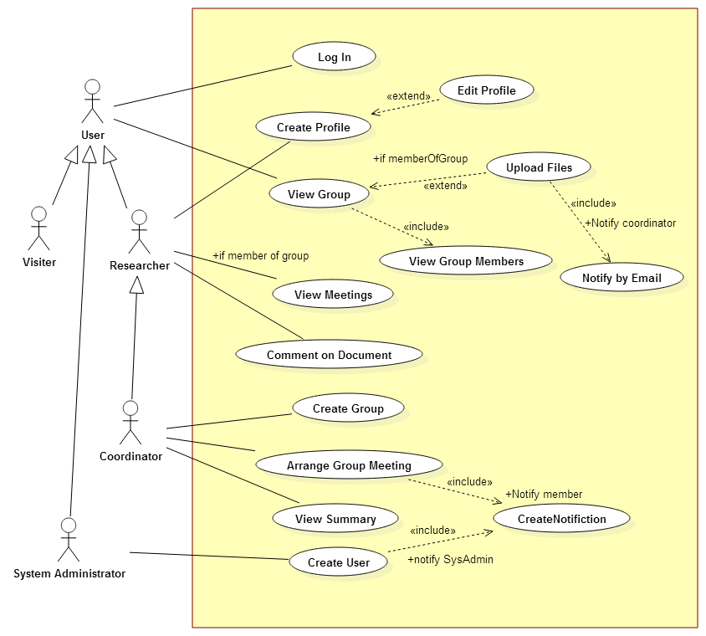

# Requirements Analysis

## In Scope

* Users should be able to log into the system using their username and password
* Researchers can participate in multiple groups
* Groups have one coordinator
* Coordinators act as system administrators for the system
* Coordinators enrol users in the system
* Coordinators set up the research groups
* Coordinators can create meetings
* Users of groups are notified when meetings are created
* Group participants can upload documents that are only visible to members of that group
* Uploaded documents have date and version control
* Coordinators can see access records of documents
* Users are notified when documents are uploaded
* Users can post comments on documents
* Users can edit their profile information
* Group members can create threads in the group that are only visible to members of that group
* Users can see who is in their group and view other member’s profiles
* Notifications will be created within the system

## Out of Scope

* Coordinators cannot leave their Groups
* Meetings do not have an associated discussion thread
* Users cannot decline from meetings
* System admins only activate user accounts. They do not create users
* Email will not be used to send notifications

# Package Diagram

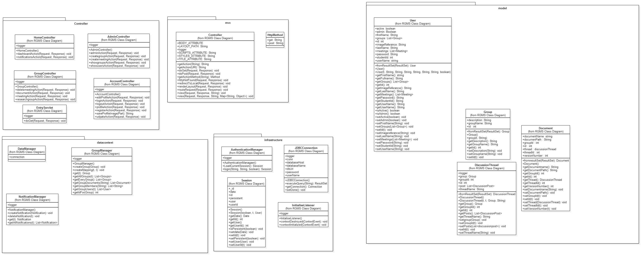



# Class Diagram

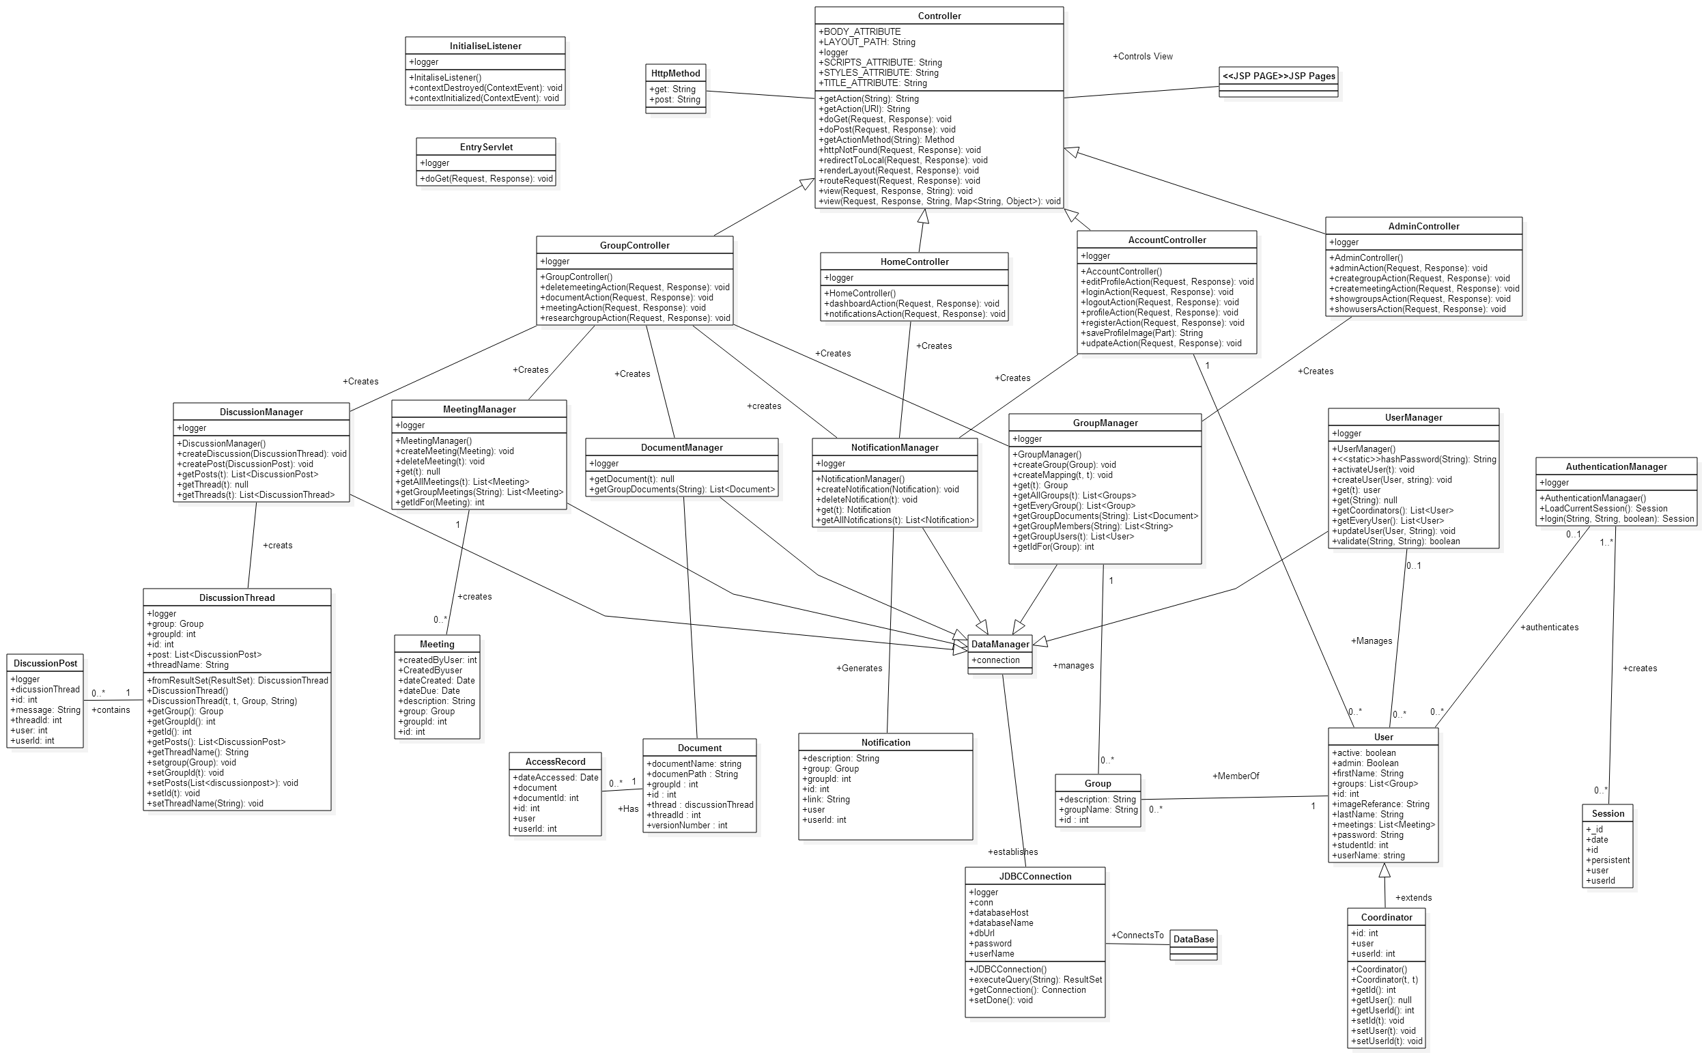

# Sequence Diagrams

## Login

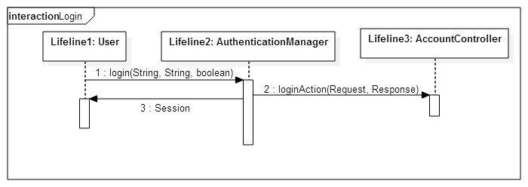

## Create Profile

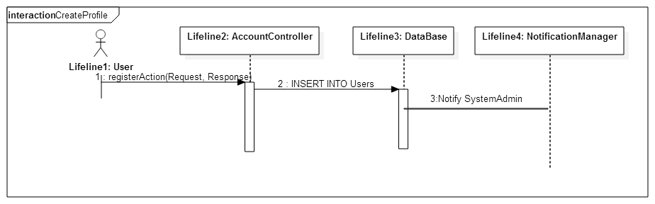

## Edit Profile

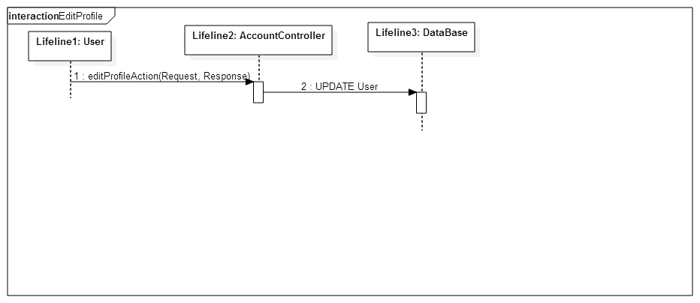

## View Group

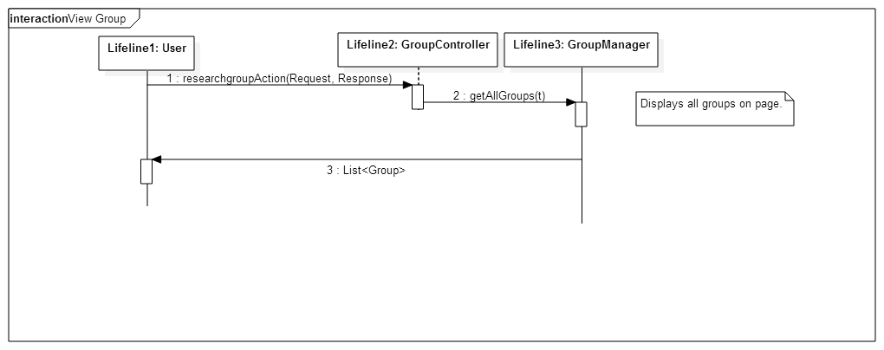

## Upload Files

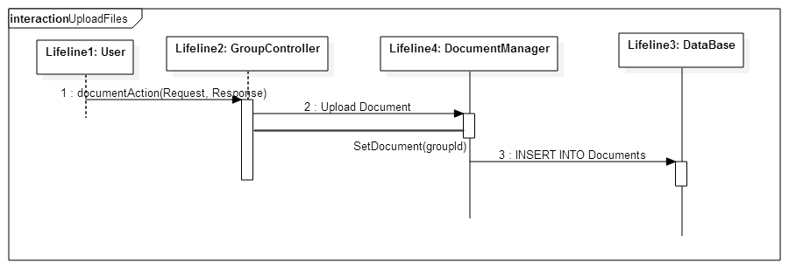

## View Meetings

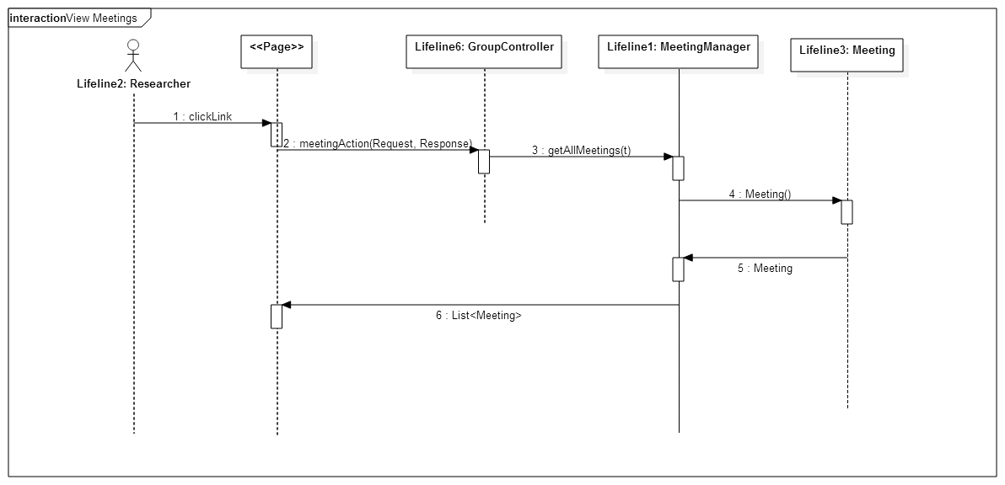

## Comment on Document

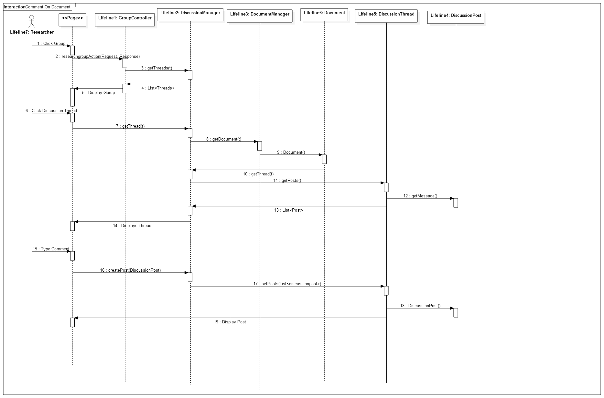

## Create Group

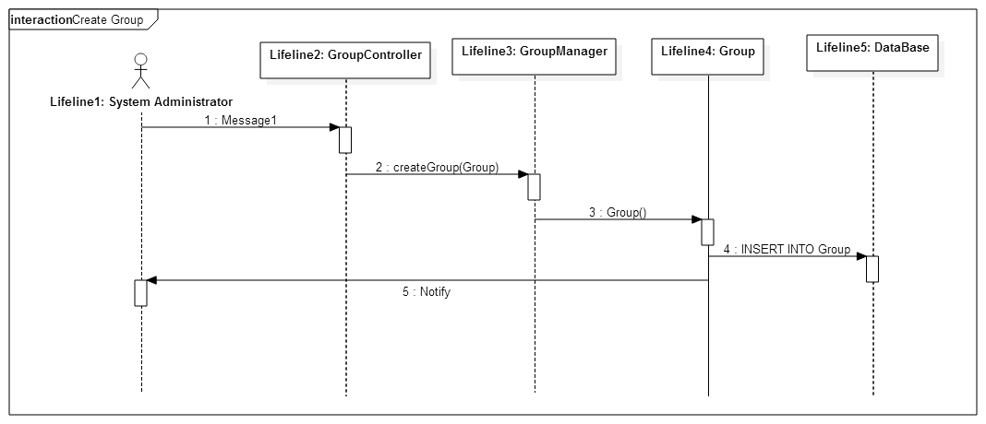

## Arrange Group Meeting

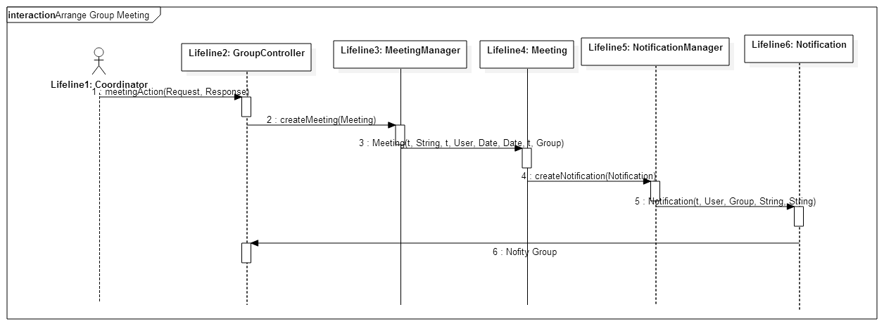

## View Summary

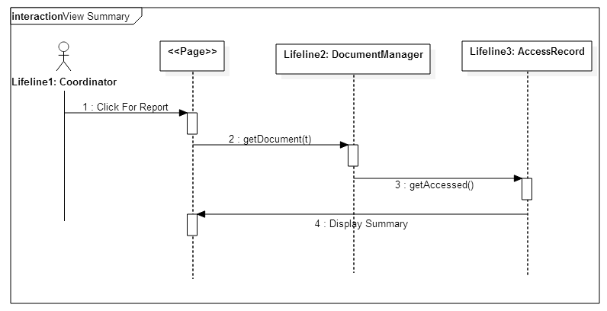

## Create User

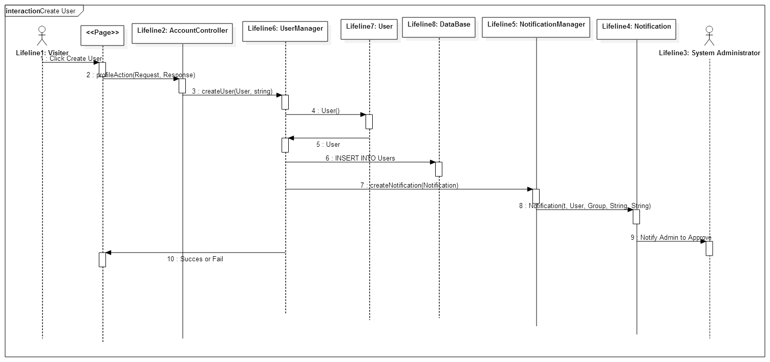

## View Group Members

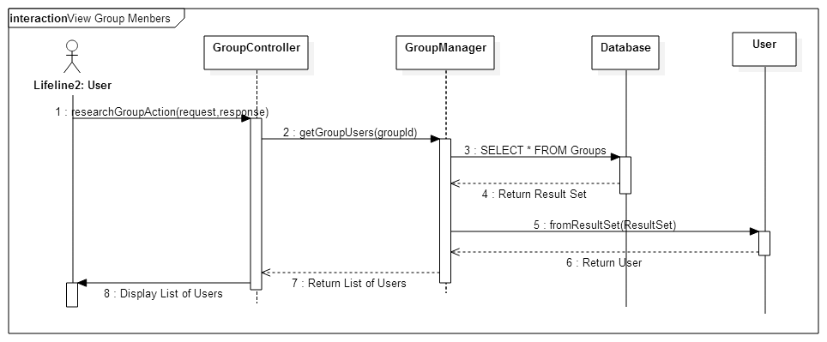

## Create Notification

